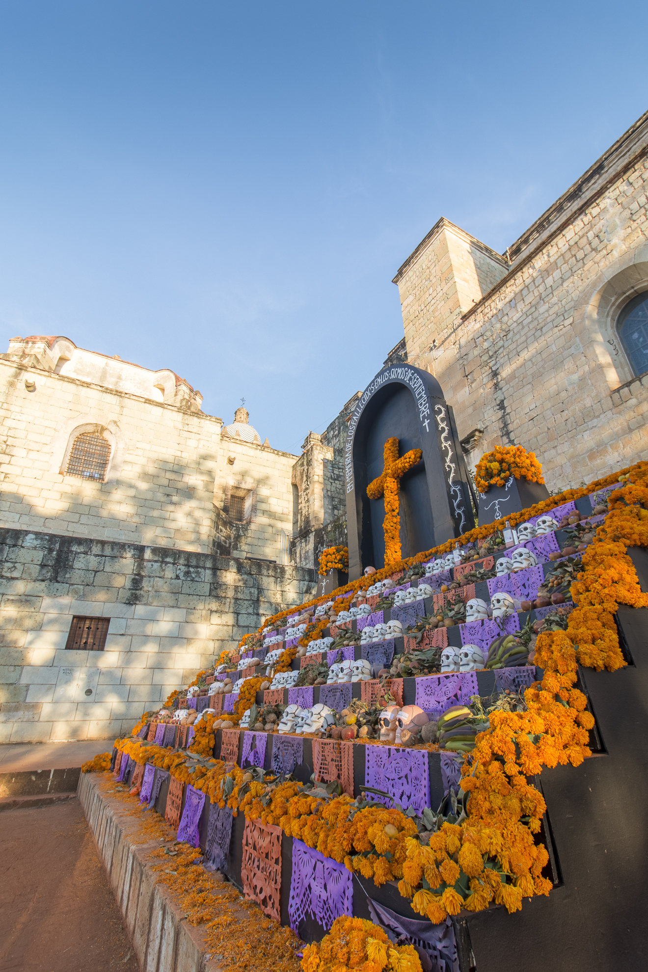



SAMPLE ITINERARY

DAY OF THE DEAD IN OAXACA 2020 WITH MEXICO CITY EXT.

DAY OF THE DEAD IN OAXACA 2020 WITH MEXICO CITY EXTENSION

- Custom Itinerary -

Experience a Day of the Dead celebration like no other, first traveling to Mexico City for an exploration of the capital before heading to Oaxaca for a fully immersive dive into the world’s most intriguing festival of life and death! Starting on October 25, enjoy 10 days on a private tour, experiencing the full spectrum of the Dia de Muertos festivities.

From vibrant and colorful street parades to poignant and intimate displays in the family home, this unforgettable vacation is the ultimate way to experience everything Day of the Dead has to offer.

Please note: Prices start at $2,800 USD for two people for the Mexico City extension and $2,000 USD per day for two people for the Oaxaca days.

**DAY-BY-DAY ITINERARY**

#### DAY 1: ARRIVE IN MEXICO CITY, FOLKLORIC BALLET OR LUCHA LIBRE SHOW – OCT 25

After landing at Mexico City airport, enjoy a private transfer to the hotel.

Take some time to settle in and – depending on the arrival flight time – enjoy the world-famous Mexico City Folkloric Ballet (Ballet Folklorico). Alternatively, head to Arena Mexico for a night of high-flying wrestling at a Lucha Libre show.

For a quieter evening, guests may prefer to try one of the capital’s many excellent gourmet dining options instead.

Overnight: [Four Seasons Mexico City](https://www.journeymexico.com/hotel/four-seasons-mexico-city)

#### DAY 2: TEOTIHUACAN PYRAMIDS AND HISTORIC CENTER – OCT 26

A day uncovering Mexico’s rich and fascinating history awaits. First, journey to Teotihuacán, one of the most important Mesoamerican sites in the Americas, where a personal, expert guide, will take the lead, visiting the site’s most important ruins, including the world’s third and fourth largest pyramidal structures, the Pyramids of the Sun and the Moon.

Then, head back to the city for a tour of its famous historic center to learn about Mexico’s past by visiting the capital’s iconic landmarks.

Please note: Visits to the interior of the National Palace, El Templo Mayor, and the Palace of Fine Arts are closed to the general public on Mondays. However, guests can still admire these historical buildings and archeological site from the outside.

Overnight: [Four Seasons Mexico City](https://www.journeymexico.com/hotel/four-seasons-mexico-city)

#### DAY 3: COYOACAN AND MUSEUM VISITS – OCT 27

See a lesser-known side of Mexico City by exploring charming Coyoacán, a traditional neighborhood of cobbled streets, colonial churches, noisy local markets, coffee shops, and quaint squares.

Take the chance to visit the Dolores Olmedo Museum for their traditional Day of the Dead exhibition and admire art pieces honoring the holiday’s traditions.

Then, head to the famous Casa Estudio de Diego Rivera, the former home of Mexican icons and artists Diego Rivera and Frida Kahlo. See the workshop and original works by both Rivera and Kahlo.

After returning to the hotel, freshen up for an evening in Zinco Jazz Club, considered one of the best nightclubs in the city.

Overnight: [Four Seasons Mexico City](https://www.journeymexico.com/hotel/four-seasons-mexico-city)

**DAY 4: ARRIVAL IN OAXACA – OCT 28**

After breakfast and hotel check out, take a private transfer from the hotel to Mexico City Airport for a commercial flight towards Oaxaca (not included).

Arrive in Oaxaca and enjoy a private transfer to the hotel. Spend the rest of the day at leisure, relaxing at the accommodation or strolling the streets of Oaxaca.

For dinner, take the opportunity to explore Oaxaca’s world-famous culinary scene by taking an expertly guided food tour or heading to one of the city’s many fine gourmet restaurants.

Accommodation: *Hotel Quinta Real Oaxaca*

**DAY 5-6: EXPLORE OAXACA – OCT 29-30**

Spend two days getting to know the true Oaxaca, a city of infinite beauty, before the Day of the Dead celebrations get into full swing. With an expert guide taking the lead, visit the city’s highlights such as its plazas and architectural gems.

A further exploration of the food is a must. Sample local delicacies including Oaxacan cheese and grasshoppers and, perhaps, head to the traditional chocolate mills to see how they work and taste Oaxaca’s specialty chocolate.

Guests may also opt to explore Mexico’s much-loved spirit, mezcal, explore the archeological site of Mitla, or get creative with a private cooking class in Mexico’s culinary capital.

**DAY 7: DAY OF THE DEAD MARKETS WITH LOCAL HOME VISIT – OCT 31**

Begin the Day of the Dead experience in Oaxaca’s sprawling markets, watching the locals prepare for the festivities by purchasing fresh bread, candles, incense, sugar skulls, and more. This is a great chance to pick up a gift or two for loved-ones back home.

Guests may also want to see how traditional Day of the Dead altars are created, while learning all about their significance and the role they play in the holiday.

A humbling experience comes when you’re invited, as a special guest, to the homes of local Oaxacans to see the alters they have created for their dead relatives. After, try traditional pan de muerto bread and the hot chocolate that goes with it.

Finally, when the night draws in, head to a cemetery for a twilight vigil and to see how the locals adorn graves with flowers and candles.

**DAY 8-9: DAY OF THE DEAD PARADE AND CULTURAL ACTIVITIES – NOV 1-2**

As the Day of the Dead celebrations reach their peak, witness the famous Dia de Muertos parades in Oaxaca’s north valley, in which locals dress up in a variety of colorful skeleton-themed costumes and march through the streets.

Guests may also want to take the chance to visit Monte Alban archeological site, one of the oldest cities in Mesoamerica, or venture to one of the nearby villages to discover Oaxaca’s rich traditions for producing artisanal, home-made products.

**DAY 10: DEPARTURE DAY – NOV 3**

On departure day, enjoy a private transfer from the hotel to the airport for onward flights home.